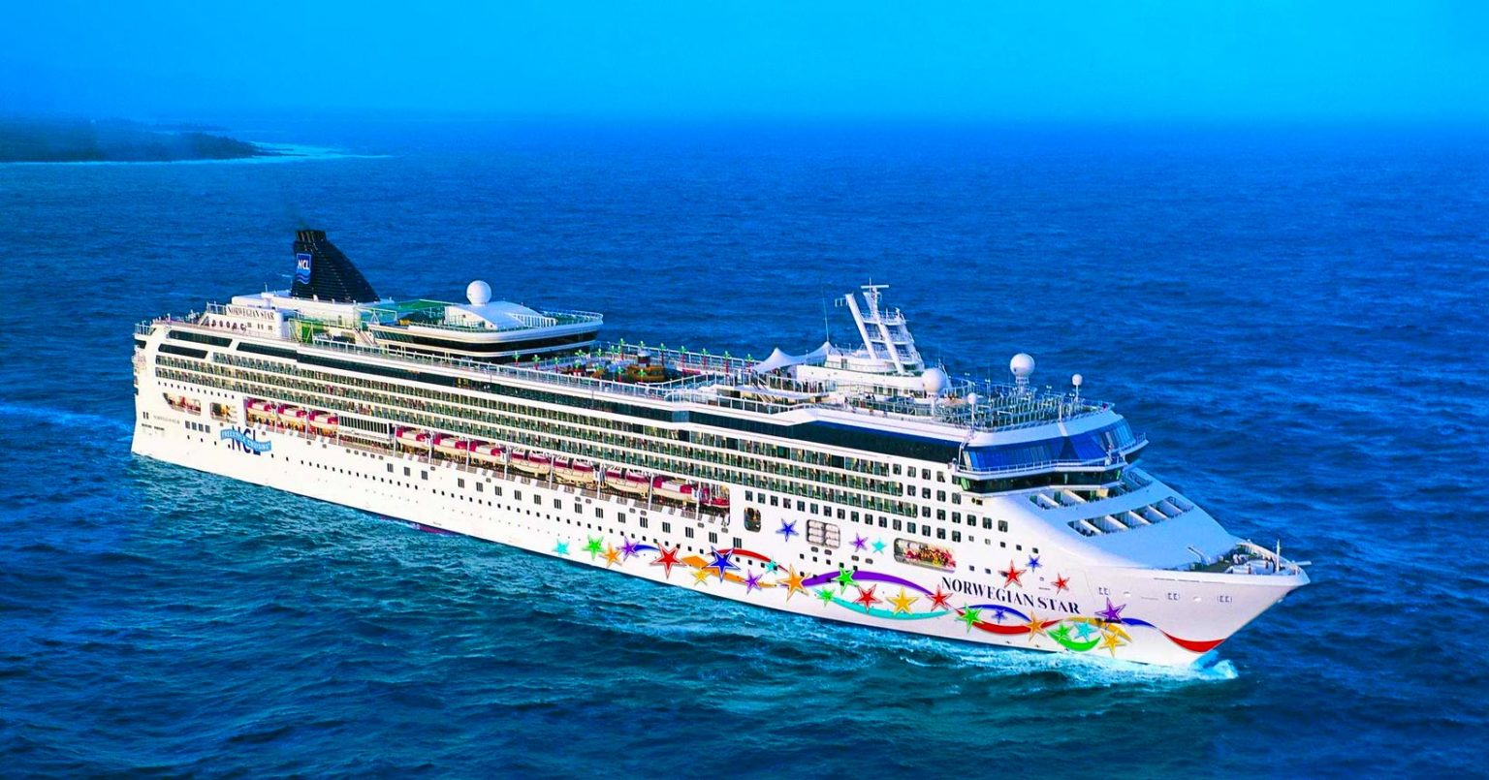

**ITINERAR**

|  |  |  |  |  |  |
| --- | --- | --- | --- | --- | --- |
| **Day** | **Date** | **Time** | **Activity** | **Port of Call** | **Country** |
| **Sun** | **12/22/2024** | **06:45 PM** | **DEPART** | **BUENOS AIRES** | **ARGENTINA** |
| **Mon** | **12/23/2024** | **08:00 AM** | **ARRIVE-DOCK** | **MONTEVIDEO** | **URUGUAY** |
| **Mon** | **12/23/2024** | **04:00 PM** | **DEPART** | **MONTEVIDEO** | **URUGUAY** |
| **Tue** | **12/24/2024** | **12:00 AM** | **CRUISE** | **(none)** | **(none)** |
| **Wed** | **12/25/2024** | **07:00 AM** | **ARRIVE-DOCK** | **PUERTO MADRYN** | **ARGENTINA** |
| **Wed** | **12/25/2024** | **04:00 PM** | **DEPART** | **PUERTO MADRYN** | **ARGENTINA** |
| **Thu** | **12/26/2024** | **12:00 AM** | **CRUISE** | **(none)** | **(none)** |
| **Fri** | **12/27/2024** | **08:00 AM** | **ARRIVE-TENDER** | **PUNTA ARENAS** | **CHILE** |
| **Fri** | **12/27/2024** | **04:00 PM** | **DEPART** | **PUNTA ARENAS** | **CHILE** |
| **Fri** | **12/27/2024** | **04:01 PM** | **CRUISE** | **CRUISE CHILEAN FJORDS** | **CHILE** |
| **Sat** | **12/28/2024** | **10:00 AM** | **ARRIVE-DOCK** | **USHUAIA** | **ARGENTINA** |
| **Sat** | **12/28/2024** | **05:00 PM** | **DEPART** | **USHUAIA** | **ARGENTINA** |
| **Sun** | **12/29/2024** | **12:00 AM** | **CRUISE** | **(none)** | **(none)** |
| **Mon** | **12/30/2024** | **12:00 AM** | **CRUISE** | **CRUISING PARADISE ISLAND** | **ANTARCTICA** |
| **Tue** | **12/31/2024** | **12:00 AM** | **CRUISE** | **ELEPHANT ISLAND/CAPE ISLAND** | **ANTARCTICA** |
| **Wed** | **01/01/2025** | **12:00 AM** | **CRUISE** | **(none)** | **(none)** |
| **Thu** | **01/02/2025** | **06:00 AM** | **ARRIVE-TENDER** | **STANLEY** | **FALKLAND ISLANDS (MALVINAS)** |
| **Thu** | **01/02/2025** | **04:00 PM** | **DEPART** | **STANLEY** | **FALKLAND ISLANDS (MALVINAS)** |
| **Fri** | **01/03/2025** | **12:00 AM** | **CRUISE** | **(none)** | **(none)** |
| **Sat** | **01/04/2025** | **12:00 AM** | **CRUISE** | **(none)** | **(none)** |
| **Sun** | **01/05/2025** | **05:45 AM** | **ARRIVE-DOCK** | **BUENOS AIRES** | **ARGENTINA** |

Itinerariul poate suferi modificari.

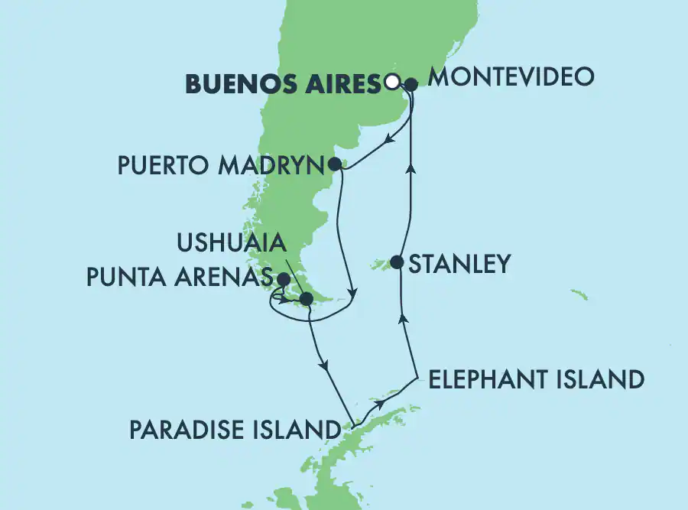

## Tariful include:

* 14 nopti cazare in functie de tipul de cabina ales(tarife dinamice-se pot modifica)
* Pensiune completa
* Participarea la activitatile de la bordul navei de croaziera: divertisment zi si noapte, spectacole de comedie;
* Utilizarea echipamentelor de fitness, teren de sport, piscine, Jacuzzi.

## Tariful nu include:

* articolele puse la vanzare in magazinele de la bord
* excursiile optionale la tarm
* bauturile alcoolice si non alcoolice servite la bord
* internetul
* asigurarea medicala
* service Charge-ul 20$/ zi/ persoana
* taxele portuare €322.00/ PERS
* ***bilete avion aprox 2700 euro/pers***
* ***transferuri-aeroport-hotel-vas croaziera-hotel-aeroport aprox 150 euro***
* ***cazare suplimentara Buenos Aires 2 nopti la dus-una la retur aprox 300 euro/pers***
* ***tururi oras Buenos Aires respectiv Rio de Janeiro***
* ***cascada Iguazú***

## Conditii rezervare:

Orice croaziera confirmata atrage o plata, in maxim 48 ore, din partea clientului sau agentiei partenere de minim 25% iar diferenta se achita cu pana la 95 zile inainte de imbarcare pentru cabine standard si cu pana la 115 zile pentru Garden Villas si suite superioare.

**Conditii de anulare** (raportate la data de imbarcare):

|  |  |
| --- | --- |
| **Cabine standard** | **Garden villas & suite superioare** |
| mai mult sau egal cu 91 zile – penalizare 25% 90 – 61 zile – penalizare 50%  60 – 31 zile - penalizare 75%  Mai putin sau egal cu 30 zile – penalizare 100% | mai mult sau egal cu 106 zile – penalizare 25% 105 – 91 zile – penalizare 50%  90 – 61 zile - penalizare 75%  Mai putin sau egal cu 60 zile – penalizare 100% |

## Norwegian Star

Norwegian Star strabate Europa pe perioada verii, din superba Copenhaga catre Marea Baltica si Fiordurile Norvegiei, iar iarna navigheaza din Tampa prin Marea Caraibilor. Special construita pentru a se alinia conceptului Freestyle, nava ofera 17 restaurante cu diferite specialitati din intreaga lume precum si 11 baruri si loungeuri. Rasfatati-va in linistea Mandara Spa, bucuratu-va si luati parte la activitatile de divertisment: de la spectacole superbe in Teatrul Stardust, la adrenalina oferita de Casino si frumusetea dansurilor si muzicii in Spinnaker Lounge fiecare seara este una de petrecere necontenita.

|  |  |  |
| --- | --- | --- |
| **Norwegian STAR – FACILITATI LA BORD** | | |
| **Baruri & Lounges** | **Restaurante** | **Divertisment, Sport & Piscine** |
| » Java Cafe | » O'Sheehan's Neighbourhood Bar & | » Barong Spa |
| » Spinnaker Lounge | Grill | » Teren de Basket/ volley |
| » Star Club Casino | » Cagney's Steakhouse | » Plase de Golf |
| » 5 O’Clock Somewhere Bar | » Ginza (asiatic) | » Jacuzzi |
| » Topsiders Bar&Grill | » La Cucina (italian) | » Piscina |
| » Bier Garten | » Le Bistro (frantuzesc) | » Internet Cafe |
| » Gatsby’s Champagne Bar | » Sushi | » Pista de alergat |
| » Sake Bar | » Teppanyaki | » Planet Kids/ club pentru copii |
| » O'Sheehan's Neighbourhood | » Versailles Main Dining Room | » Magazin Port o’Call |
| Bar & Grill | » Aqua Main Dining Room | » Piscina pentru copii |
|  | » Market Cafe/ Kid’s Cafe | » Casino Star Club |
|  | » Carlo’s Bake Shop | » Teatru Stardust |
|  | » Topsiders Bar&Grill | » Club adolescenti |
|  | » Moderno Churrascaria | » Boutique Trade Route |
|  |  | » Biblioteca |
|  |  | » Oasis: Piscina exterioara |
|  |  | » Sala de Jocuri |
|  |  | » Crama |
|  |  | » Barong/ Sala fitness |
|  |  | » Barong/ Bar |

## Family Inside Cabina Interioara

Pot gazdui de la 2 persoane (interioare duble) sau 3,4 persoane (interioare family). Suprafata: aprox. 13 mp.

## Cabina exterioara

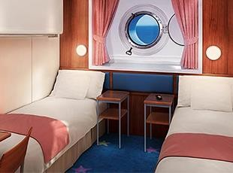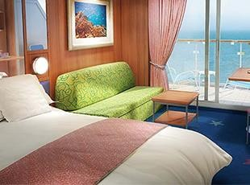

Sunt cabine cu hublou/ fereastra cu o suprafata de 15 mp. si care pot gazdui 2 pers. Cabinele exterioare family pot gazdui pana la 4 pers.

## Cabina cu balcon

Acest tip de cabina poate gazdui pana la 3 pasageri si ofera balcon propriu. Suprafata: aprox 19 mp. Cabinele cu balcon family dispun de un pat matrimonial si o canapea. De asemenea intalnim si cabine conectate.

## Mini-Suite with Balcony Mini suite cu balcon

Mini apartamentele sunt dotate cu pat queen size, o baie luxoasa si balcon propriu. Pot gazdui pana la 4 pasageri si au o suprafata de aprox. 26 mp.

# Freestyle cruising – conceptul definitoriu Norwegian Cruise Line

In anul 2000 Norwegian Cruise line a fost pionierul unui concept alternativ de a lua masa si, in decursul acestui proces, a revolutionat experienta culinara oferita de Industria de Croaziere. Din acel moment Norwegian Cruise Line si-a extins alegerile in restarante pentru a include orice de la tapas la teppanyaki. Selectia cuprinde multiple posibilitati fantastice de a lua masa, incluse in tariful croazierei, si o varietate de restaurante de specialitate create in mod particular pentru “iesirile de seara”.

## Restaurante incluse in tariful croazierei.

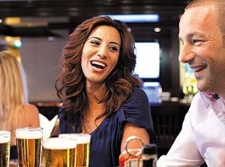**O'Sheehan's Neighborhood Bar & Grill**

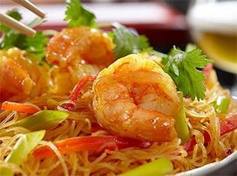Luati masa intr-un pub irlandez reinventat pe masura ce savurati sortimentul preferat de bere la draft, totul intr-o atmesfera casual. Restaurantul este deschis 24h/24h.

## Ginza Restaurant Asiatic

O aventura plina de savoare in gastronomia asiatica, o fuziune abila a ceea ce este mai bun din bucataria japoneza, thai si chinezeasca.

## Versailles

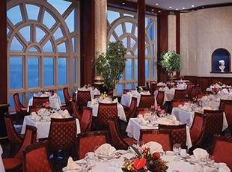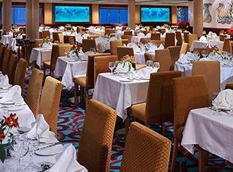

Fiecare fel este pregatit cu atentie si dedicatie de catre bucatarii sefi ai Norwegian Cruise Line, membri ai societatii Chaine de Rotisseurs, recunoscuta la nivel Mondial.

## Aqua

Da, sunteti la bordul unei nave insa nu este niciun motiv sa nu va bucurati de toate deliciile culinare pe care le poate oferi orice oras mare al lumii. Preparatele sanatoase si light sunt parte integranta a meniului oferit aici.

## The Garden Cafe and Kids CafeMarket Café/Kid's Café

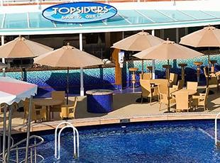Restaurantul bufet ofera o varietate extraordinara de mancaruri din bucataria internationala si locul preferat de a lua masa a familiilor cu copii.

## Topsiders Bar & Grill

Este perfect pentru a lua masa in aer liber, fiind situat in apropierea Piscinei Oasis.

|  |  |  |
| --- | --- | --- |
| **CATEGORY** | **CABIN TYPE** | **PRICE/pers/loc in dbl** |
| Sail Away Inside(IX)- | Inside | 1,958 € |
| Inside(IF) | Inside | 1,971 € |
| Inside(IB) | Inside | 1,997 € |
| Inside(IA) | Inside | 2,004 € |
| Family inside(I4) | Inside | 2,017 € |
| Sail Away Oceanview(OX) | Oceanview | 2,335 € |
| Obstructed Oceanview(OK) | Oceanview | 2,348 € |
| Oceanview(OF) | Oceanview | 2,381 € |
| Oceanview with Picture Window(OA) | Oceanview | 2,641 € |
| Family Oceanview(O4) | Oceanview | 2,927 € |
| Sail Away Balcony(BX) | Balcony | 3,161 € |
| Balcony(BF) | Balcony | 3,174 € |
| Balcony(BA) | Balcony | 3,369 € |
| Aft-Facing Balcony (B1) | Balcony | 3,512 € |
| Sail Away Club Balcony Suite(MX) | Suite | 3,882 € |
| Club Balcony Suite(MB) | Suite | 3,895 € |
| Club Balcony Suite(MA) | Suite | 3,960 € |
| Family suite(SP) | Suite | 5,000 € |
| Aft-Facing Penthouse with Balcony(SN) | Suite | 5,241 € |
| AFft-Facing Penthouse with large Balcony(SM) | Suite | 5,494 € |
| Forward-Facing Penthouse with Large Balcony(SF) | Suite | 5,676 € |
| 2-Bedroom Deluxe Family Suite with Balcony (S4) | Suite | 7,819 € |
| Deluxe Owner Suite(S6) | Suite | 8,127 € |

Shore Excursions

**Highlights Of Montevideo**

**Montevideo, Uruguay**

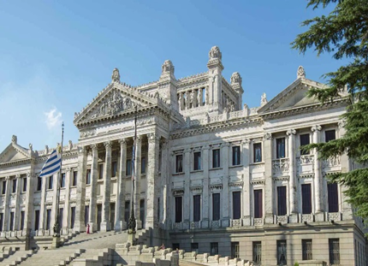

**Duration : 3½ Hours Level 1:Easy Scenic&City Tours**

***Starting from: 81 euro/adl***

**Maritime History Walk- Stanley, Falkland Islands**

**Duration : 2¼ Hours Level 2:Moderate Scenic&City Tours**

***Starting from: 90 euro/adl***

**Stanley On Foot Stanley, Falkland Islands**

**Duration : 2¼ Hours Level 2:Moderate Scenic&City Tours**

***Starting from: 90 euro/adl***

**Stanley Walking Tour**

**Stanley, Falkland Islands**

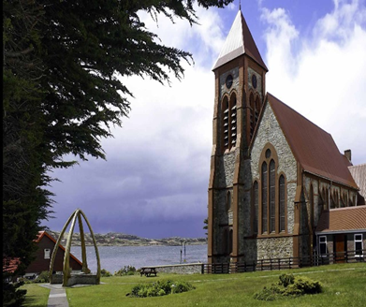

**Duration : 2¼ Hours Level 1:Easy** **Scenic&City Tours**

***Starting from: 90 euro/adl***

**Falkland Battlefields Stanley, Falkland Islands**

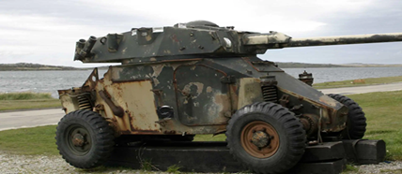

**Duration : 2½ Hours Level 1:Easy Historical Landmarks**

***Starting from: 90 euro/adl***

**Punta Arenas Highlights Punta Arenas, Chile**

**Duration : 3¼ Hours Level 2:Moderate Scenic&City Tours**

***Starting from: 99 euro/adl***

**Stanley Highlights Stanley, Falkland Islands**

**Duration : 2¼ Hours Level 1:Easy Scenic&City Tours**

***Starting from: 99 euro/adl***

**Go Local - Explore Montevideo Like a Local Montevideo, Uruguay**

**Duration : 4¼ Hours Level 2:Moderate Scenic&City Tours**

***Starting from: 117 euro/adl***

**Patagonian Dinosaurs & Punta Loma Reserve Puerto Madryn, Argentina**

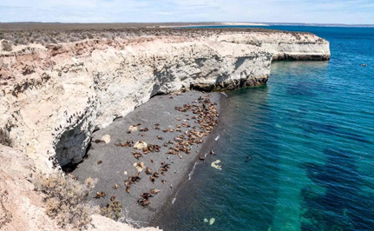

**Duration : 3½ Hours Level 2:Moderate Wildlife Tours**

***Starting from: 126 euro/adl***

**A Voyage to the Past - Sailors & First Inhabitants Punta Arenas, Chile**

**Duration 3¼ Hours Level 2:Moderate Scenic&City Tours &Historical Landmarks**

***Starting from: 126 euro/adl***

**Highlights Of Montevideo & Tango**

**Montevideo, Uruguay**

**Duration 4½ Hours Level 2:Moderate Scenic&City Tours &Historical Landmarks Music&Dancing**

***Starting from: 135 euro/adl***

**Fort Bulnes & Magellan´s Strait Park Punta Arenas, Chile**

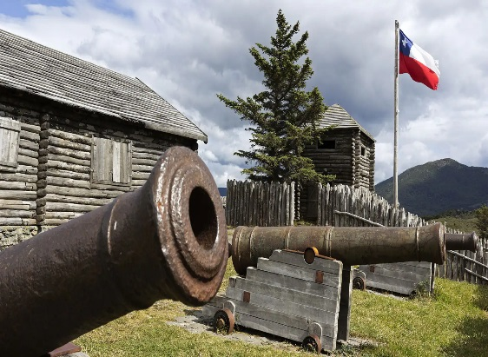

**Duration 4½ Hours Level 2:Moderate Scenic&City Tours &Historical Landmarks**

***Starting from: 135 euro/adl***

**Trekking At Andino Park Punta Arenas, Chile**

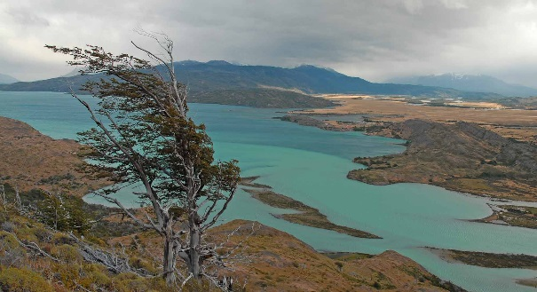

**Duration 3½ Hours Level 3:Challenging Adventure**

***Starting from: 135 euro/adl***

**Falkland Nature Trek Stanley, Falkland Islands**

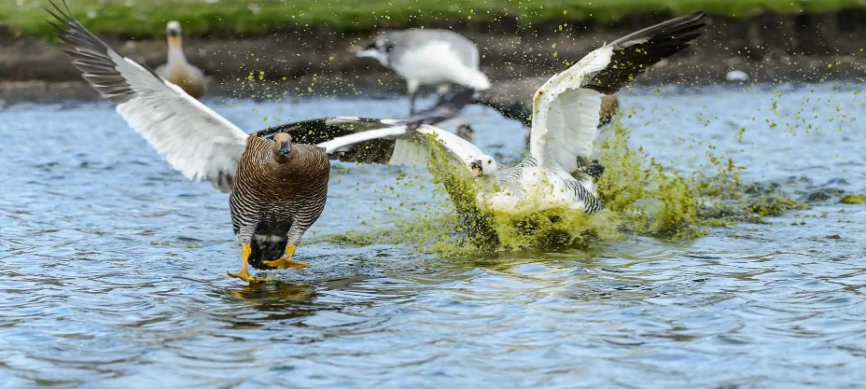

**Duration 3¼ Hours Level 3:Challenging Adventure**

***Starting from: 135 euro/adl***

**Tierra Del Fuego National Park Ushuaia, Argentina**

**Duration 4¼ Hours Level 1:Easy Scenic&City Tours**

***Starting from: 144 euro/adl***

**The Tycoons Of Patagonia Punta Arenas, Chile**

**Duration 4¼ Hours Level 2:Moderate Scenic&City Tours Historial Landmarks**

***Starting from: 144 euro/adl***

**Penguin Rookery Navigation Ushuaia, Argentina**

**Duration 4½ Hours Level 1:Easy Scenic&City Tours & Wildlife Tours**

***Starting from: 162 euro/adl***

**End of the World Wilderness Trek Ushuaia, Argentina**

**Duration 4½ Hours Level 2:Moderate Adventure**

***Starting from: 171 euro/adl***

**Go Green-Eco-Farm Experience at the End of the World Ushuaia, Argentina**

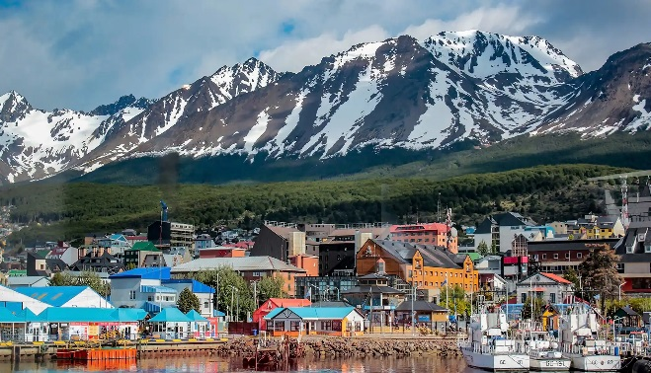

**Duration 6½ Hours Level 2:Moderate**

***Starting from: 207 euro/adl***

**The Lagoon Bluff Stanley, Falkland Islands**

**Duration :3¼ Hours Snack Provided**

**Level 2 :Moderate**

***Starting from: 216 euro/pers***